React – JS
1.React Js is an javascript library
2.React JS is a component based Architecture. Using this components to devide the code different components(subblocks)

Node Js + VS Code (text editor)

Create Project for React-JS
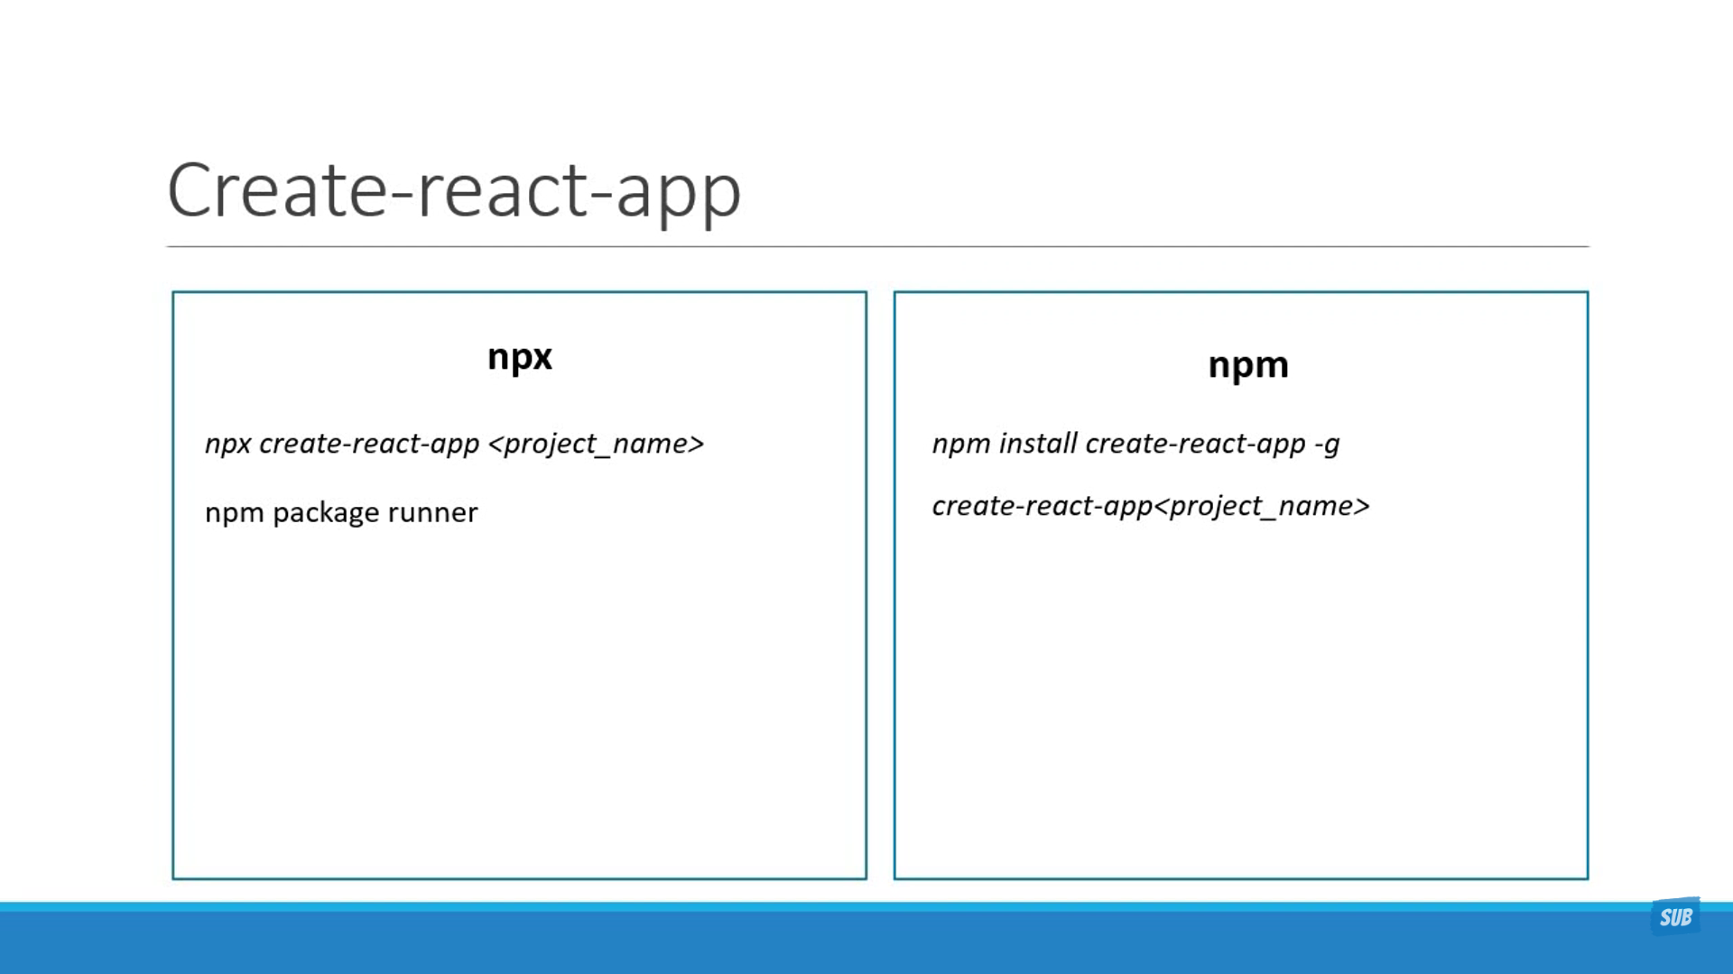
NPM Start this will execute the code
Package.json it contains all dependency scripts
Ng-module it contains all dependencies
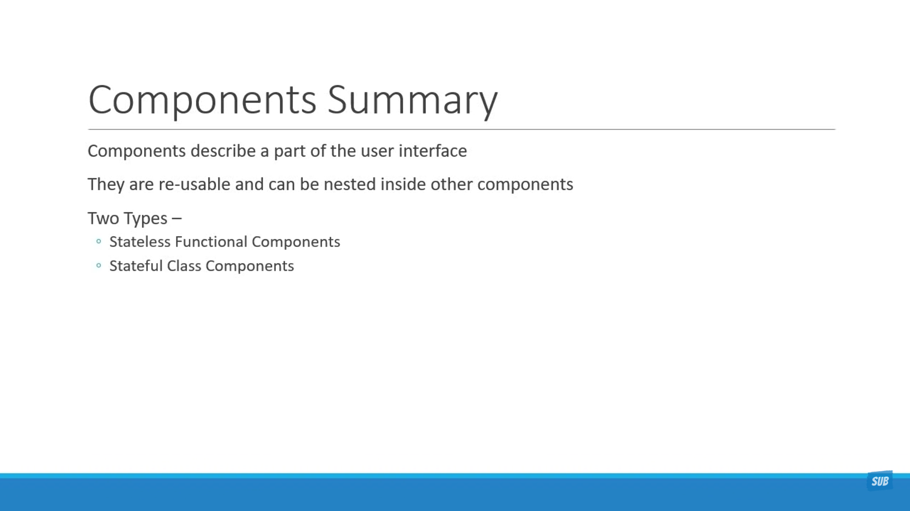
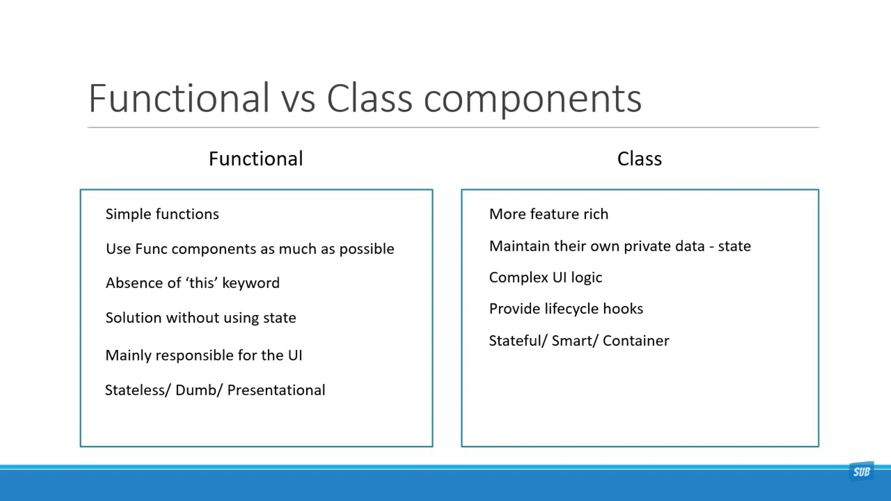

Props props are immutable. That means we cant assign the value

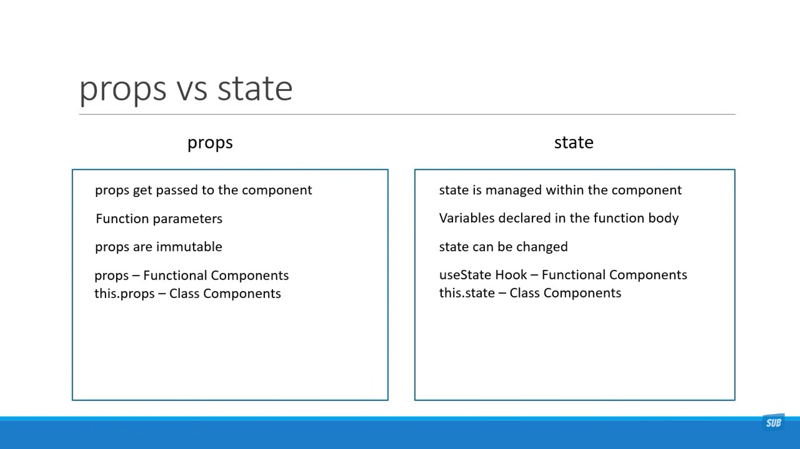

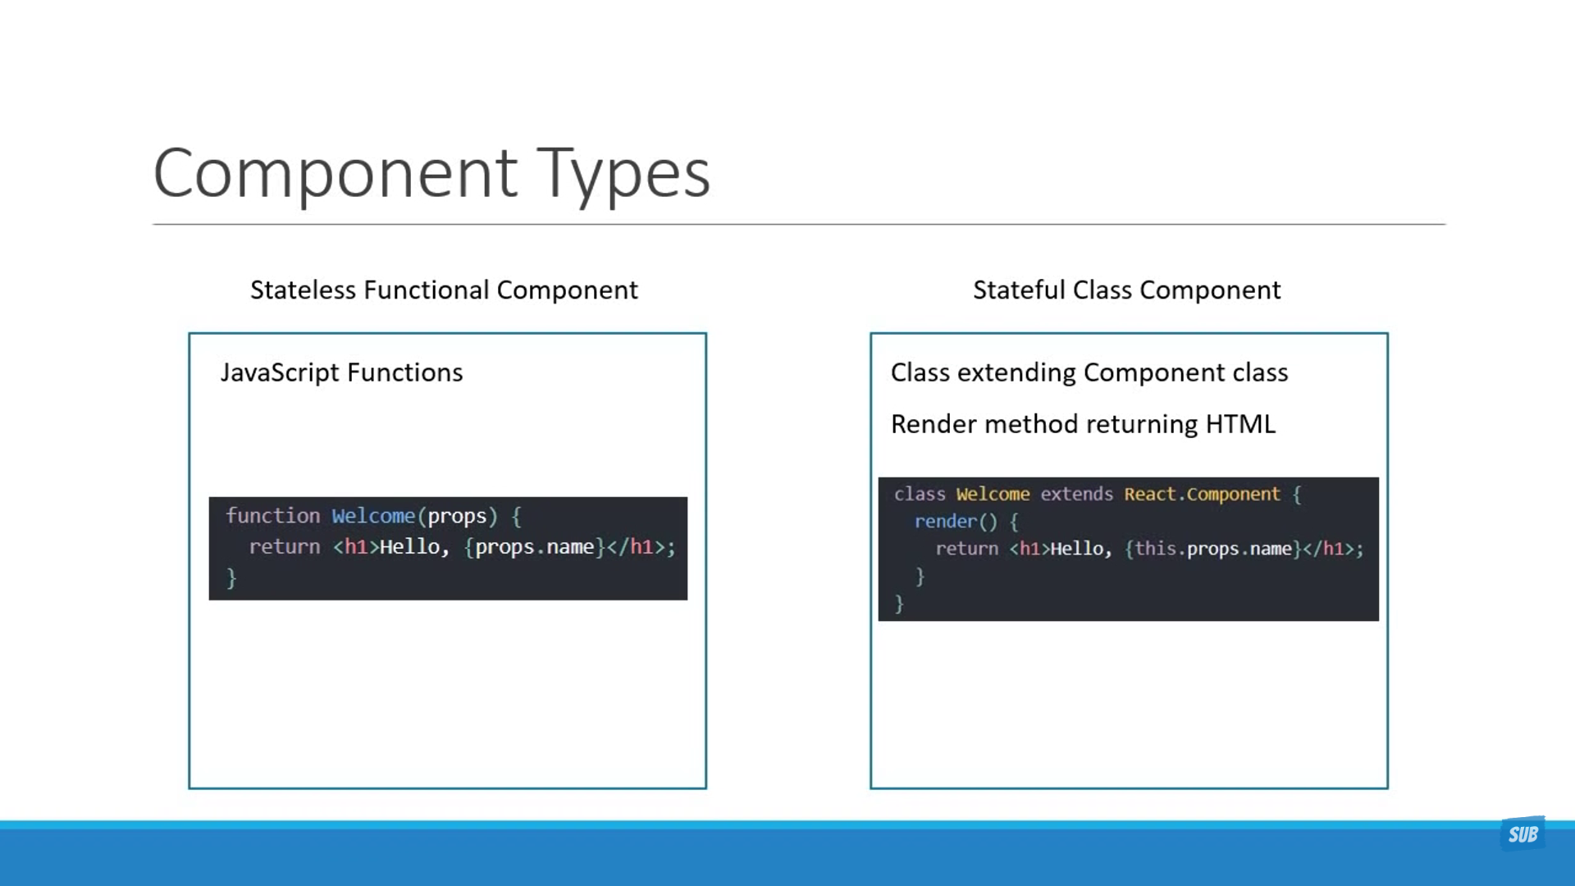
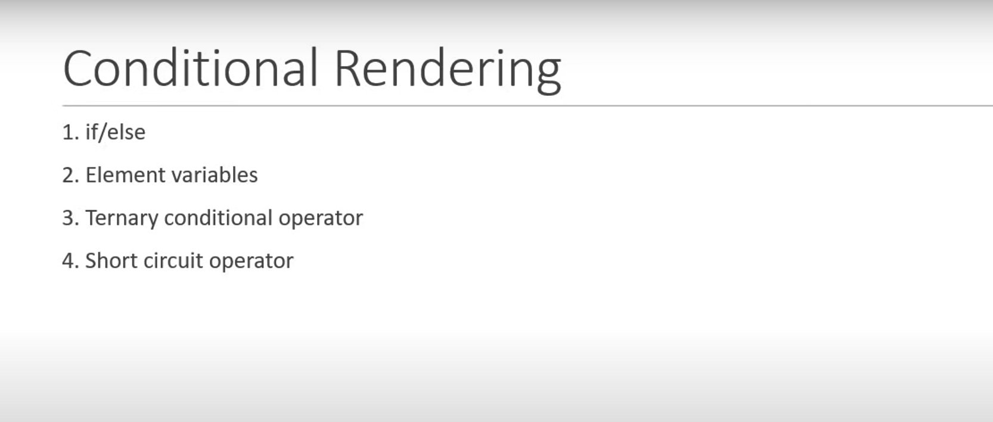
If the value is true then it results something and if the value is false then it will not return anything

List Rendering:
Using Map metod:
import React, { Component } from "react";

class NameList extends Component{
constructor(){
super()

}

render(){
const name=['kota','sai','Ande']
let mes=name.map(ele=><h2>{ele}</h2>)
return(
<div>
{ mes}

</div>
)
}
}
export default NameList

Export & Import
1.naming import that will return object type so while importing we need distructure
Import {count} from ‘./component/count’

2.Normal import we are using default while exporting so no need to distructure
Import count from ‘./component/count’

Hooks:
1.hooks we can use in function component only. We cant use in class component
2.hooks we cant use in if conditional statements
3.hooks we need to use inside the function component only

useState() this function is one part of hooks
this function used to store the value
this function return two values 1. Value 2.function

